BCIIT

BCASemIV

LabManual1-WebDevelopmentthroughDjango(BCA-218)

|  |  |  |
| --- | --- | --- |
| Excercise1 | **Installpythonincludinginstallationofpip,installationandsettingupvirtualenvironment&Installationof Django.** | status |
|  |
| Excercise2 | **Createanewdjangoprojectusingcommandline.** |  |
| Excercise3 | **Createanapplicationwith‘Helloworld’.** |  |
| Excercise4 | **Createadjangoappthatwilldefineurlpatternatapplicationlevelinsteadof projectlevel.** |  |
| Excercise5 | **Createadjangoapplicationwithmultipleviewfunctions.** |  |
| Excercise6 | **CreateadjangoapplicationusingtemplatefeaturesRenderingatemplate**  **Multiple ContextContexvariable**  **Templateloadingincludetemplatetag.** |  |
| Excercise6 | **Createa django appwith dynamiccontentfromviewfunction.** |  |
| Excercise7 | **Createadjangoappwithdynamicgreettextonserver.** |  |
| Excercise8 | **Createadjangoappwithloadingofstaticfilesusingjinja2templatelanguage.** |  |
| Excercise9 | **Createadjangoappthatwillcontainsstaticfilesincludingimages,media&cssfiles.** |  |
| Excercise10 | **Createadjangoappwithadvancedtemplatefeatures.** |  |
| Excercise11 | **Apptoconnecttemplateswithmodelstoserver datadynamically.** |  |
| Excercise12 | **RenderingamodelinDjangoAdminInterface** |  |
| Excercise13 | **Writeadjangowebapptouseparametersfromviews.py** |  |
| Excercise14 | **Writeadjangowebappusingcontrolstatements.** |  |

Excercise1: **Installpythonincludinginstallationofpip,installationandsettingupvirtualenvironment&Installationof Django.**

Step 1: Install Python from official Docs.

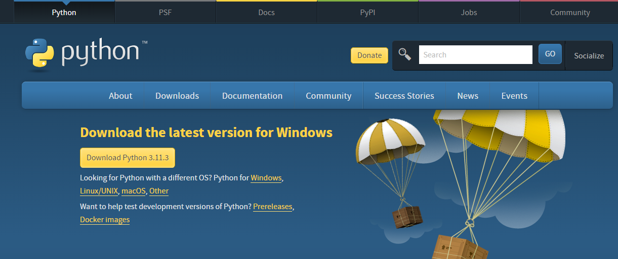

Step2:

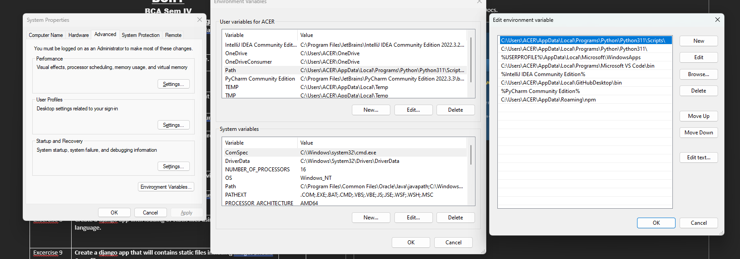

Step3:

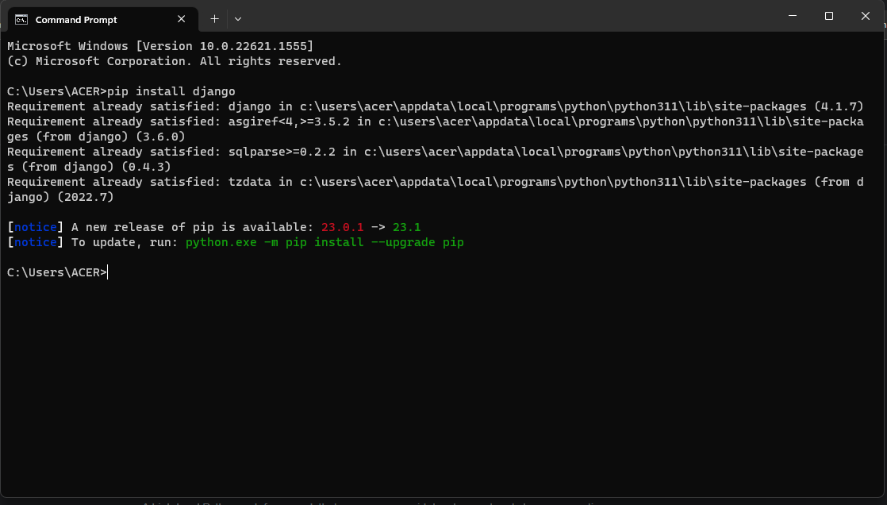

Excercise2. **Createanewdjangoprojectusingcommandline.**

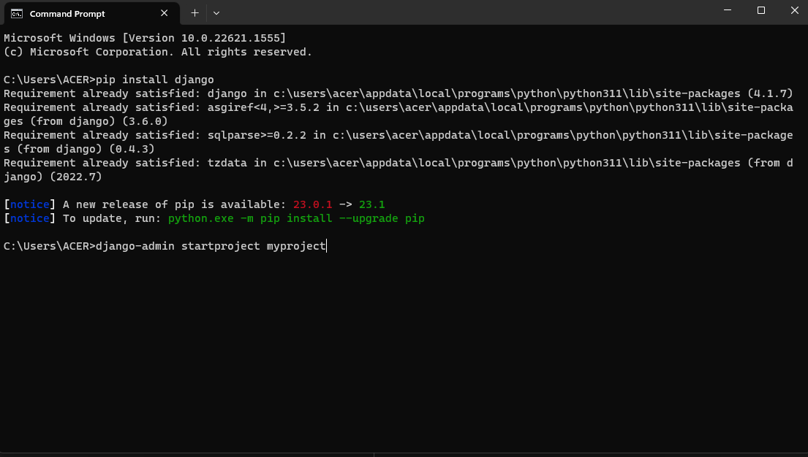

Excercise3, 4. **Createanapplicationwith‘Helloworld’ and Createadjangoappthatwilldefineurlpatternatapplicationlevelinsteadof projectlevel.**

Step1: **urls.py:**

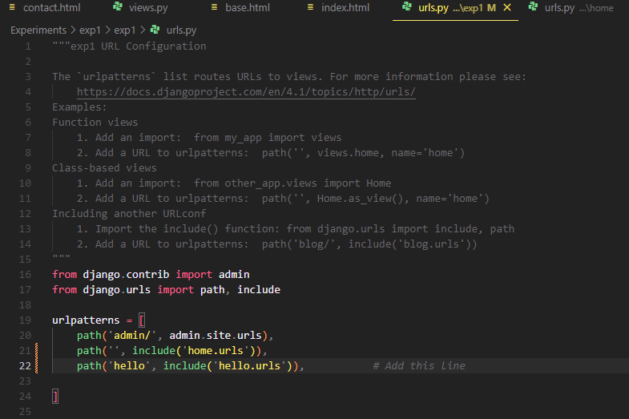

Step2: create a app in your Django project using below command line

“py manage.py startapp hello”

Step3: create a urls.py in your hello app

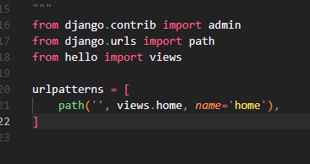

Step4: Define home function in views.py

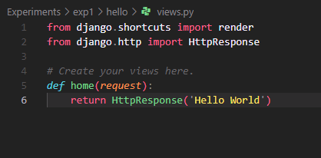

Excersice 5, 6A, 6B, 7, 8, 9, 10, 11

Step1: create a Django home app in your Django project using below command

“py manage.py startapp home”

Step2: Go to views.py and create multiple views function

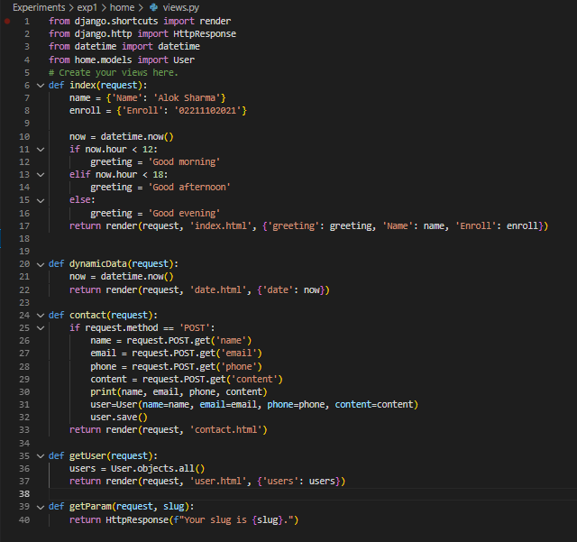

Step4:For rendering template go to settings.py file and edit “TEMPLATES_DIR” to “BASE_DIR / ‘templates’ “

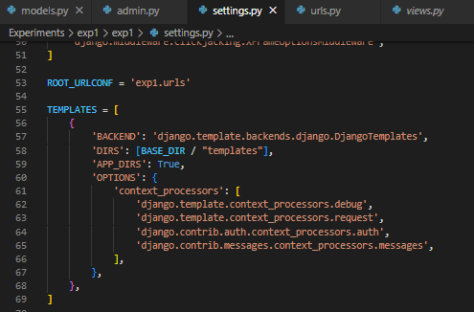

Step5: create “base.html” and “index.html” inside the templates folder

And add at the top of the index.html {% extends ‘base.html’ %}

Base.html:

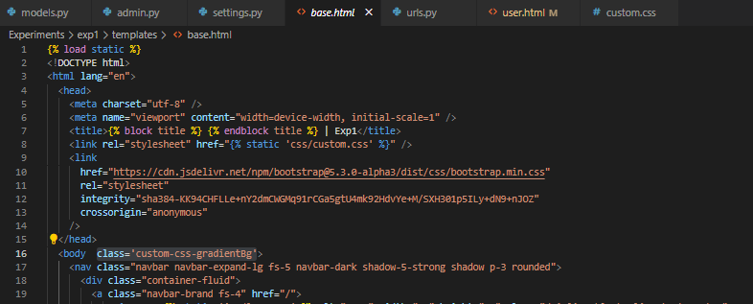

Index.html:

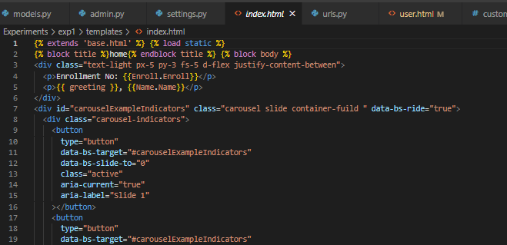

Step5: To add static file in webpage, firstly you need to add STATIC_DIR in settings.py

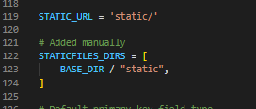

Step6: goto static directory and create a folder for called “img” and move all the required images inside the static folder

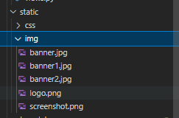

Step7: to display static images on your webpage use {% static load ‘img/img_name’ %}



Endresult:

